God is Hearing the Russian People & Elites Deluded
July 11, 2016
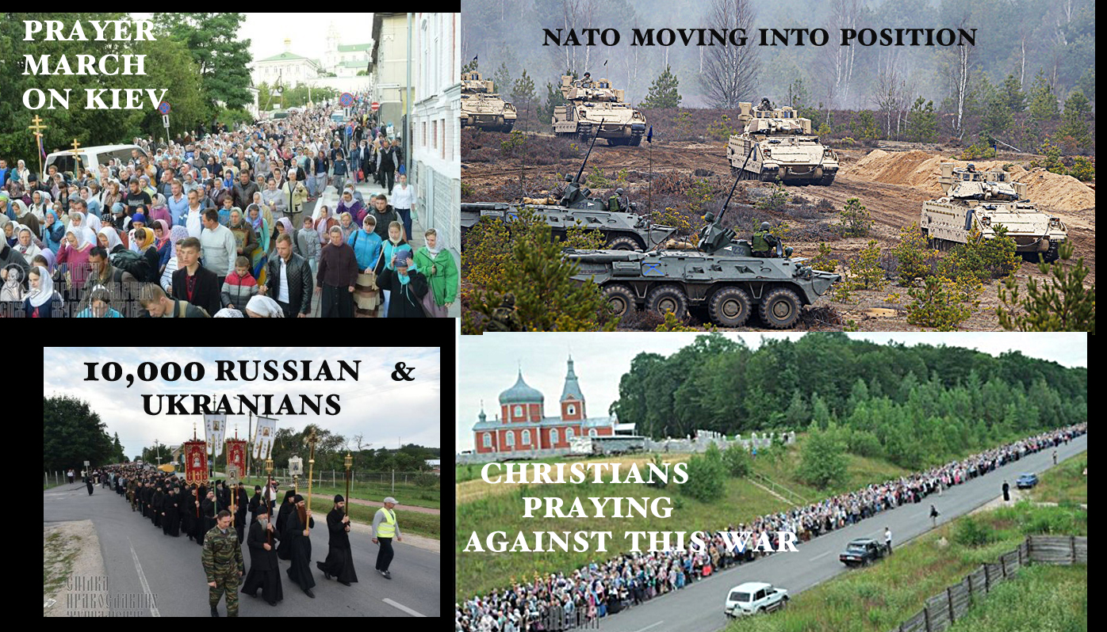
Lift up your heads, Heartdwellers. Your redemption draws nigh.

Tonight, the Lord was with me in a banquet hall and an elaborately beautiful ballroom. I could actually hear the rustle of my wedding dress and see certain satin parts of it as we danced across the floor. At one point, after several moments, I began to see other brides in their gowns with their Jesus, gracefully twirling and moving to the sound of the music. The Lord kept my focus here the entire time of my worship.

So, when I came to listen to Him, I began with: Thank You, Lord, for bringing me into a preview of the wedding banquet. I cannot tell if it is because it is soon or so very far away that you are allowing me to experience this. Although I know you have been speaking to Ezekiel, my husband, about it every day. Tonight he said that he felt you were trying to get him to lift up his eyes, for his redemption draws nigh. In other words: 'Keep your eyes on the signs that say it is soon. Keep your eyes on the prize.' And yet his pain is off the charts and things are heading towards a climax politically in this country.

Lord, please, bring us something.

Lord, are You here?

"I am here, Beloved, and nothing is happening quite yet. Steady as she goes. I know you are all ready to make an exit. But the situation is not quite ripe yet and souls are pouring in from Muslim nations.

"The situation is critical in Poland. Many, many prayers are going up from the Russian people, because they do not want to be forced into this war that your sick leader is pushing for. The Father is hearing these prayers, Clare. This evil man is going to be frustrated into doing some very foolish things. God Himself is withstanding him.

"There are people among the elite that have lost their minds and their perspectives. It is the grassroots that are holding this world together right now. The deluded elites are pushing against God, Who is withstanding them. There have now been so many delays, that things are beginning to fall apart at the seams for them. There are underground bases and 'incubators', so to speak, that are beginning to overflow, running out of space, backed-up waiting. And it is causing a deterioration of focus that is seriously compromising a move forward for them.

"This is My Father’s doing. Man has his plans but power is from on High and God will not be mocked or forced into anything. So, it is back firing on them. Tensions are growing, internal breakdowns are happening as avenues expected to be open for action and moving forward are closed tightly shut.

"Deterioration, frustration and internal disintegration are happening among those who thought the world would be thrown into confusion and destroyed by now. You, My Brides, are not the only ones waiting anxiously for the Rapture."

And at this point, I just wanted to share that I had a vision/impression this whole time the Lord was speaking. I saw a great army of sorts in waiting and they have come to a precipice where they can go no further and are there. Yet thousands are behind them who are still in forward motion and being brought to an abrupt halt by those who have stopped at the precipice. It’s like a massive traffic jam…backed up for miles. I don’t know if this represents the mental or the physical state of readiness of opposing forces. But frustration is obvious.

Jesus continued. "As I said, deterioration from inside is going on. That is a very good sign. There are still plenty of good people in this world that oppose this. And yes, Mr. Trump is key; I am using him to wake the world up."

Lord, it is all so confusing to me. It seems as though we have a chance to rebuild this country and the world - and I don’t see how the Rapture fits in with that at all.

"You are correct, but not all the forces of evil have been harnessed, Clare; there is still much hidden from the world."

But will the Father allow the Rapture as long as the world is turning around?

"That is a good question. I cannot answer that at this time, Beloved. You are getting a little too curious and looking into things far beyond you. However, I have to say your logic is sound; you just don’t know about the forces of evil that play into this."

You mean like the demon-aliens and their part? (You see guys, I never give up...!!)

“Yes. And more you know nothing of. But I will say this: the prayers of the poor people of the world, the grassroots, the real humans of this world are having an impact on events that is slowing down what the elites have planned. You see, AntiChrist cannot be revealed until those who are holding back the wrath with their prayers are removed. There will be a point where the scales tip, but for now there is still balance. I know you want Me to give you more, Clare, but I cannot."

So, what is Your counsel to us, Lord?

“Steady as she goes. Lifting up holy hands in prayer and supplication that this evil will be stopped, and that what must take place will take with it the greatest harvest of souls. And after prayer, action.

"Pursue your missions, My Bride. Continue on in the right direction bringing forth fruit with your gifts. For some of you, the gift is sickness and sufferings of various kinds. I am with you in your bed of suffering, My Brides. I will comfort you with great tenderness and gratefulness for your loving and giving heart.

"Know that the greatest players in this semi-final scene are My faithful intercessors. The little ones no one sees or cares about. They are the decisive force; they are in the front lines and holding back the tide of evil. If you are one of them, I beg you to find honor and great satisfaction in this role. You are the ones making the greatest difference.
"Persevere and be highly satisfied for your exalted stations in this moment of history. Great will be your reward in Heaven. Do not look to what others are doing and compare yourself. No, press in with your heart focused on My intentions; press in and raise the cry for justice on high to the Father’s throne. Yours is the decisive voice.

"This is a war zone, and you are the front lines. I am sustaining you. Great is the glory associated with a love that gives and gives beyond itself. This was My portion and when you manifest it, you are most like Me. I am with you. Do not grow weary. Take comfort from the great joy you bring Me, My Brides.

"Because of your faithfulness, prophecy will be accomplished in a way no one could have foreseen or imagined."

